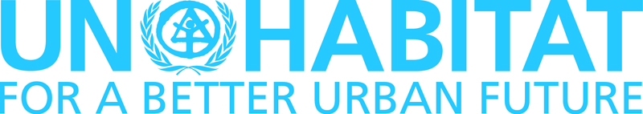

World Urban Campaign 7th Steering Committee Meeting

12-13 March 2012

VENUE: Radisson Blu Hôtel,Vieux Port, Marseille, France

Background
Launched in Rio de Janeiro in March 2010, the World Urban Campaign (WUC) is governed by a Steering Committee that was formalised at its fifth meeting in Shanghai during the 2010 Word Expo ‘Better City, Better Life’.
The Steering Committee is the WUC’s governing body and is comprised of selected UN-Habitat’s official partner organizations. The Steering Committee is responsible for establishing the campaign’s goals and objectives, defining the activities, strategies, annual workplan and setting the campaign’s governing procedures. The Steering Committee works closely with the WUC Secretariat.
The Steering Committee is composed of Sub-Committees that serve as working groups for WUC activities and are comprised of Steering Committee members. Sub-Committees help plan and bolster the campaign activities such as outreach and communication strategies, business plans, resource mobilization and knowledge sharing.
Previous Steering Committee meetings (SCM):
First SCM: 12-14 October 2009, Barcelona (Hosted by Provincial Government of Barcelona)
Second SCM: 7-9 December 2009, Paris (Hosted by IUA Région Ile de France)
Third SCM: 20 March 2010, Rio de Janeiro (hosted by Brazilian Institute of Municipal Administration)
Fourth SCM: 30 May- 2 June 2010, Alicante (hosted by the Municipality of Alicante)
Fifth SCM: 8-10 October 2010, Shanghai (hosted by CRECC, China)
Sixth SCM: 7-8 September 2011, Amsterdam (hosted by Arcadis)

The main outcomes of the last Steering Committee meeting were:
- Approval of the Campaign Communication Strategy, including a new branding and awareness-raising component entitled ‘I’m a City Changer’. The Secretariat was requested to establish two web platforms (worldurbancampaign.org and imacitychanger.org) as well as to produce new communication materials.
- Decision to establish a World Urban Campaign Fund as common resource mobilization and funding facility that allows the Campaign to deliver joint actions. In that regard, a business plan and guidelines that describes the different levels of partnership was to be prepared by the Secretariat with the core working group on resource mobilisation, to be circulated to the SCM members.
- Progress on the templates for Good Policy and Enabling Legislation that was to be finalized by the working group. All partners were requested to search for pilots case studies.
- Approval of the benchmarking tools and methods questionnaire for dissemination to the Partners for their inputs and inventory by the Secretariat.
- Decision to revitalize the 100 Cities Initiative. The Secretariat was mandated to contact the pilot cities involved in the first stage for inclusion in the new phase. Partners were requested to identify cities and city champions that could participate in the initiative with clear consideration of geographical balance by end of 2011.
- Progress on the World Urban Campaign’s Rules of Procedures on which partners were requested to provide their inputs to the Secretariat.
- Decision to hold the next Steering Committee meeting at the beginning of 2012.
The three priority goals for 2012 shall be to:
- Improve the internal and external communication for WUC partners and gain a higher visibility;
- Expand the partners and members base to strengthen the Campaign from the international to the local levels;
- Implement key activities that develop knowledge, promote learning and dialogue on cities: the catalogue of tools and methods, the global observatory on good policies and enabling legislations, the 100 Cities Initiatives.
Those goals are attainable given the level of commitment of partners, the rather solid structure in place in terms of governance, the clear thematic definition and clustering, the advanced communication strategy.

Objectives
The objectives of the 7th Steering Committee meeting will be:
- To introduce the new Secretariat structure;
- To present new communication materials and tools;
- To further develop the benchmarking tools and methods components of the Campaign;
- To carry forward the Good Policies and Enabling Legislation and 100 Cities components of the Campaign;
- To advance in the definition of the key messages of the Campaign;
- Too define next steps to increase the number of WUC partners;
- To approve the business plan;
- To define WUC’s role at Rio +20 (support to Sustainable Cities exposition);
- To agree on the content and the organization structure of the 100 Cities initiative;
- To share the World Urban Campaign and ‘I’m a City Changer’ events at the next World Urban Forum in Naples;
- To propose new ways to broaden the Campaign in order to amplify the movement towards the preparation of the Habitat III Conference.

DRAFT AGENDA
Session 1

Monday 12 March 2012

2.00 PM Introductory Plenary session

Room: Salon Romarin
- Welcoming
- Opening Statement by Dr. Joan Clos, Executive Director, UN-HABITAT
- Adoption of the meeting agenda
- Presentation by the World Urban Campaign Secretariat
  - World Urban Campaign and I’m a City Changer websites
  - World Urban Campaign Kit

- Introduction of new World Urban Campaign partners
3.00 pm Tea/Coffee break

Room: Salon Lavande

3.30 PM Plenary session

Room: Salon Romarin
1. Progress reports presented by:
  - The World Urban Campaign Secretariat
  - The World Urban Campaign Partners
  - The Working Groups
2. Key issues brought up by partners:
  - New working group or sub-group on ‘City Futures and Innovation’
  - Private sector participation and engagement with cities
  - Other issues

6.30 PM Evening Dinner Cocktail

Espace Lavande

Session 2

Tuesday 13 March 2012

9.00 AM Introductory session

Room: Salon Romarin
Three working groups will be formed to brainstorm on the following:
- Group A: Good policies and enabling legislations
- Group B: Benchmarking tools and methods
- Group C: Communication, outreach and events (e.g. Rio +20, World Urban Forum, 100 Cities)

9.30 AM-12.00 PM Working Groups

Room: salon Estragon
Group A: Good policies and enabling legislation

Room: Salon Cumin/Safran
Group B: Benchmarking tools and methods

Room: Salon Romarin
Group C: Communication, outreach and events

Tea/Coffee break will be served from 10 to 10.30 am

Room: Salon Lavande

12.30 – 2.30 PM Lunch Break

Terracotta Café

2.30 – 6.00 PM Plenary session

Room: Salon Romarin
- Working groups report to plenary
- Agreements reached by the Steering Committee
- Conclusion on the way forward
- Closing remarks

The Venue

Radisson Blu Hôtel, Vieux Port, Marseille, France
38 Quai Rive Neuve
13007 Marseille
Tel : +33 (0)4 88 92 19 50

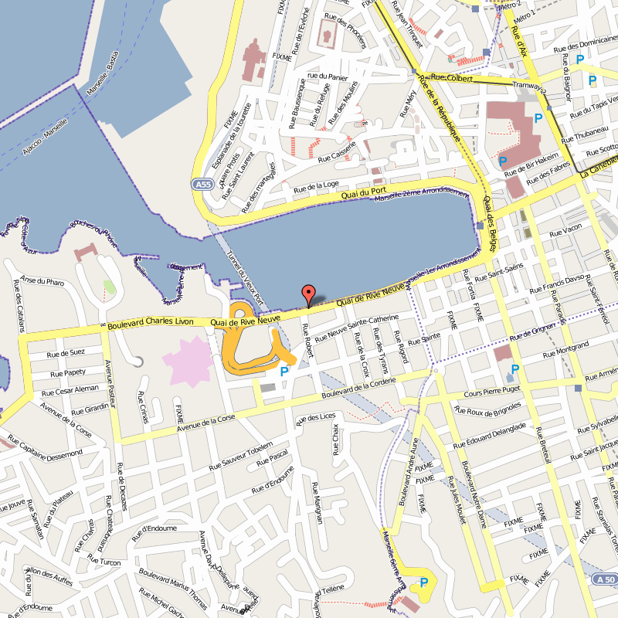

http://daccess-ods.un.org/TMP/7608031.63051605.html
Partners are requested to keep their oral presentations to a maximum of 4 minutes each as written progress reports will be included in the final report.

